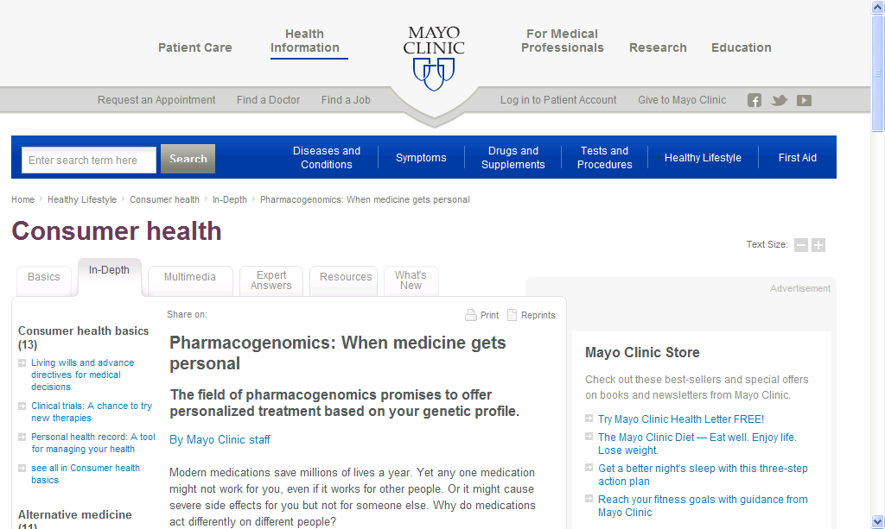
http://www.mayoclinic.com/health/personalized-medicine/CA00078

Pharmacogenomics: When medicine gets personal

The field of pharmacogenomics promises to offer personalized treatment based on your genetic profile.
By Mayo Clinic staff
Modern medications save millions of lives a year. Yet any one medication might not work for you, even if it works for other people. Or it might cause severe side effects for you but not for someone else. Why do medications act differently on different people?
Your age, lifestyle and overall health all influence your response to medications. But your genes also play a role. Scientists are working to match specific gene variations with responses to particular medications. With that information, doctors would be better able to tailor treatments to individuals.
That's what pharmacogenomics is all about. Part of an emerging field called personalized medicine, pharmacogenomics offers the promise of predicting whether a medication is likely to help or hurt you before you ever take it.

Genetics 101
Genes are segments of DNA, which are found in all of your cells. DNA is essentially a chemical operating system for your body, instructing it how to behave and interact on a cellular level. A basic gene can have many different forms. For instance, consider the gene that determines hair color. Normal variations of that gene determine specific hair color, such as brown or blond.
Similarly, your genes can determine how you react to a medication. You may have a genetic variation that makes the drug stay in your body longer than usual, causing serious side effects. Or you may have a variation that makes the medication less potent.

The promise of pharmacogenomics
Say you're diagnosed with a certain disease, such as breast cancer, for which you must take medication. You and your doctor choose a medication based on standard drug therapy and dosing guidelines. Your doctor also takes into account such factors as your weight, age, medical history and perhaps how your biological (blood) relatives reacted to the same medication.
Despite all of that, neither you nor your doctor knows how you'll actually react to the medication. You may experience terrible side effects — or none at all. The medication may put your cancer into remission — or it may have no effect. Consequently, you may have to return to your doctor many times to adjust the dosage or to switch medications. This is how medication choices generally work today — it's often a matter of trial and error.
Pharmacogenomics could potentially speed up that process. Before you take a single dose of medication, you may be able to have a test to see which genetic variations you have. If the test shows that you have a variation that's likely to adversely affect how you respond to the medication, your doctor can change the dosing or skip that drug entirely and prescribe a different one.

How is pharmacogenomics used today?
A few tests are now available that can help predict whether individuals with cancer or other diseases are likely to have good responses — or bad reactions — to certain medications. One such test is the Cytochrome P450 genotyping test. The test looks at a group of enzymes known as Cytochrome P450 (CYP450) enzymes, which are responsible for metabolizing — breaking down and eliminating — more than 30 types of medications, such as antidepressants, proton pump inhibitors, and anticoagulants such as warfarin.
Some people, because of their genetic makeup, aren't able to break down these medications fast enough. The medications can then build up in the body and cause severe side effects. Conversely, some people break down these medications too quickly — before they have a chance to work. The CYP450 test can identify people with these genetic variations so that doctors can make more-informed prescribing decisions, reducing the risk of adverse events and increasing the likelihood of treatment success.

What are some of the barriers to pharmacogenomics?
The field of pharmacogenomics is still in its early stages. It's possible that millions of genetic variations may exist, and identifying them all could take many years — if it's even possible. In addition, how you respond to a medication may not be determined by just one gene but rather by many genes interacting with each other. Combing through this complicated genetic map is expensive and time-consuming. As a result, it may be some time before pharmacogenomics is a routine part of medicine.

